**Fiction**

**Stories Set in a Familiar Setting**

**(School)**

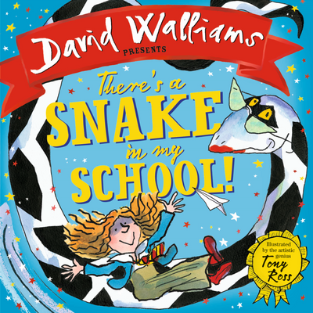

**Basic skills I will revise in this unit:**

* Orally rehearse sentences before writing
* Adding the suffixes -ing and -ed to words

**Skills I will be taught in this unit:**

* Secure the use of full stops and capital letters exclamation marks and question marks.
* Say, write and punctuate simple and compound sentences using the joining words and, but.
* Use regular past tense for narratives

***Writing Outcome:***

***I can write a story set in school.***