**Whatever Next**

**Narrative**

**Stories from the same**

**author**

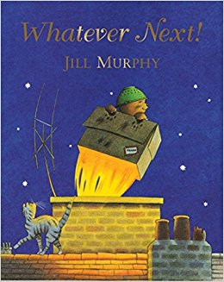

**Outcome**

To orally retell a story.

To write a series of sentences in sequence.

**Skills**

Use phonic knowledge to write unfamiliar words.

Orally compose every sentence before writing it.

Punctuate a sentence with a full stop.

To separate words with finger spaces.

Form lower case letters correctly.

**Whatever Next**

**Narrative**

**Stories from the same**

**author**



**Outcome**

To orally retell a story.

To write a sentence independently.

**Skills**

To hear sounds in words.

Orally compose a sentence and hold it in memory before attempting to write it.

Punctuate a sentence with a full stop.

To separate words with finger spaces.

Form lower case letters correctly.