TEACHING BRITISH VALUES

Promoting British Values at Thomas Gray Primary School
The DFE have recently reinforced the need “to create and enforce a clear and rigorous expectation on all schools to promote the fundamental British values of democracy, the rule of law, individual liberty and mutual respect and tolerance of those with different faiths and beliefs.”
The Government set out its definition of British values in the 2011 Prevent Strategy, and these values have been reiterated this year (2014). At Thomas Gray Primary School these values are reinforced regularly and in the following ways:

Democracy
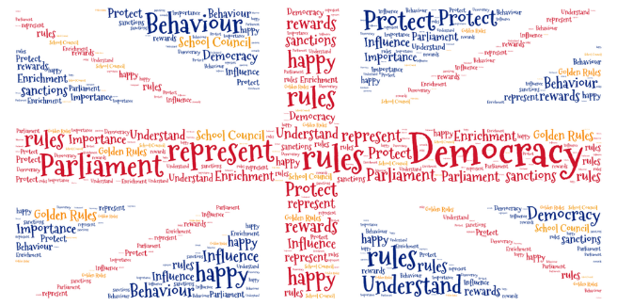

Each year the children decide upon their class mission statement and the rights associated with these. All the children contribute to the drawing up of the class mission statement. These class statements are then used by the School Council to draw up our whole school Learning Charter.
We have a school council which meets regularly with a teacher to discuss issues raised in class. The council has its own budget and is genuinely able to effect change within the school. Every child on the school council is voted in by their class. Children have an annual questionnaire where they are able to put forward their views about the school.

The Rule of Law
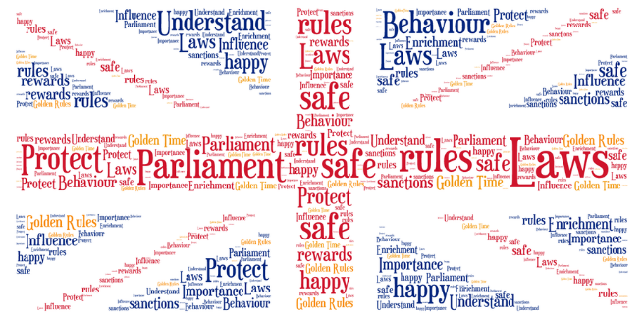

The importance of laws, whether they be those that govern the class, the school, or the country, are consistently reinforced at Thomas Gray Primary School.
Pupils are taught from an early age the rules of the school. These are our School Rules, Playground Rules and Safety Rules. Pupils are taught the value and reasons behind rules and laws, that they govern and protect us, the responsibilities that this involves and the consequences when laws are broken. Visits from authorities such as the Police and Fire Service help reinforce this message.

Individual Liberty
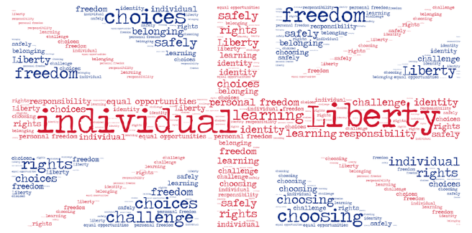

At Thomas Gray Primary School pupils are actively encouraged to make choices, knowing that they are in a safe and supportive environment. As a school we educate and provide boundaries for young pupils to make informed choices, through a safe environment and an empowering education. Pupils are encouraged to know, understand and exercise their rights and personal freedoms and advised how to exercise these safely, for example through our E Safety and PSHE lessons.

Mutual Respect
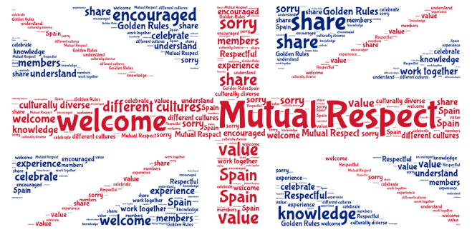

Mutual respect is at the heart of our values. Children learn that their behaviours have an effect on their own rights and those of others. All members of the school community treat each other with respect. This is incorporated into our Learning Charter and our use of bucket filling and character strengths.

Tolerance of those of Different Faiths and Beliefs
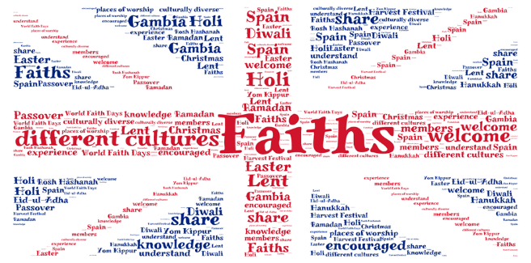

We actively promote diversity through our celebrations of different faiths and cultures. Religious Education lessons and PSHE lessons reinforce messages of tolerance and respect for others. Members of different faiths and religions are encouraged to share their knowledge to enhance learning within classes and the school. The children visit places of worship that are important to different faiths. Our annual cultural week celebrates different religions and cultures across the world.

