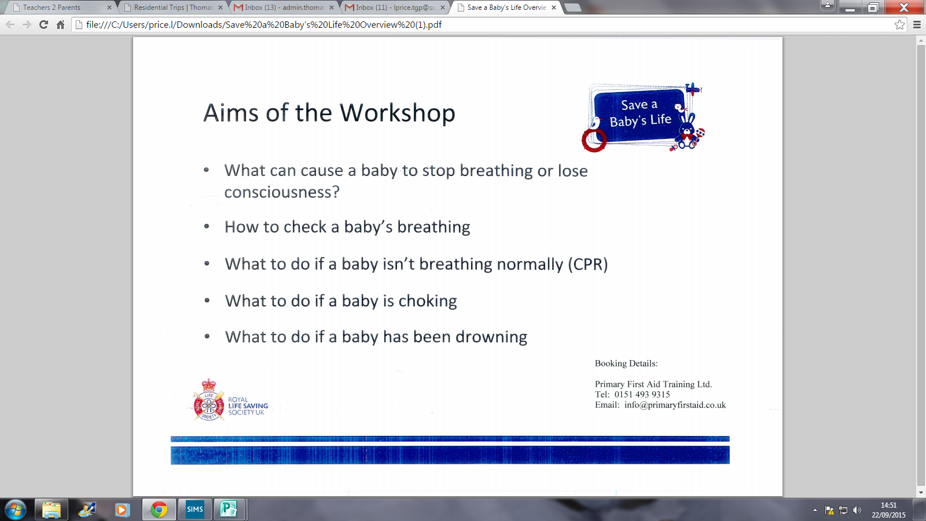

**Aims of the Workshop**

• What can cause a baby to stop breathing or lose consciousness?

• How to check a baby’s breathing

• What to do if a baby isn’t breathing normally (CPR)

• What to do if a baby is choking

• What to do if a baby has been drowning

**Time - 9.15am-11.15am**

**Venue - Thomas Gray Primary School**

**Date - Thursday 15th October 2015**

**Limited spaces available so book your place quick.**

**If you are interested in a place please give your name into the school office.**