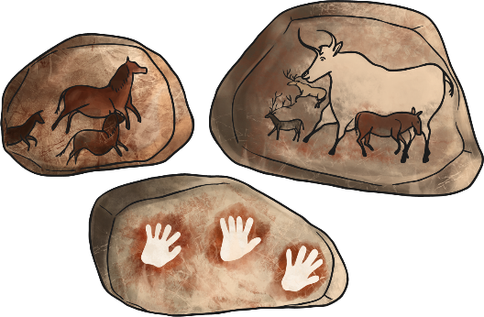
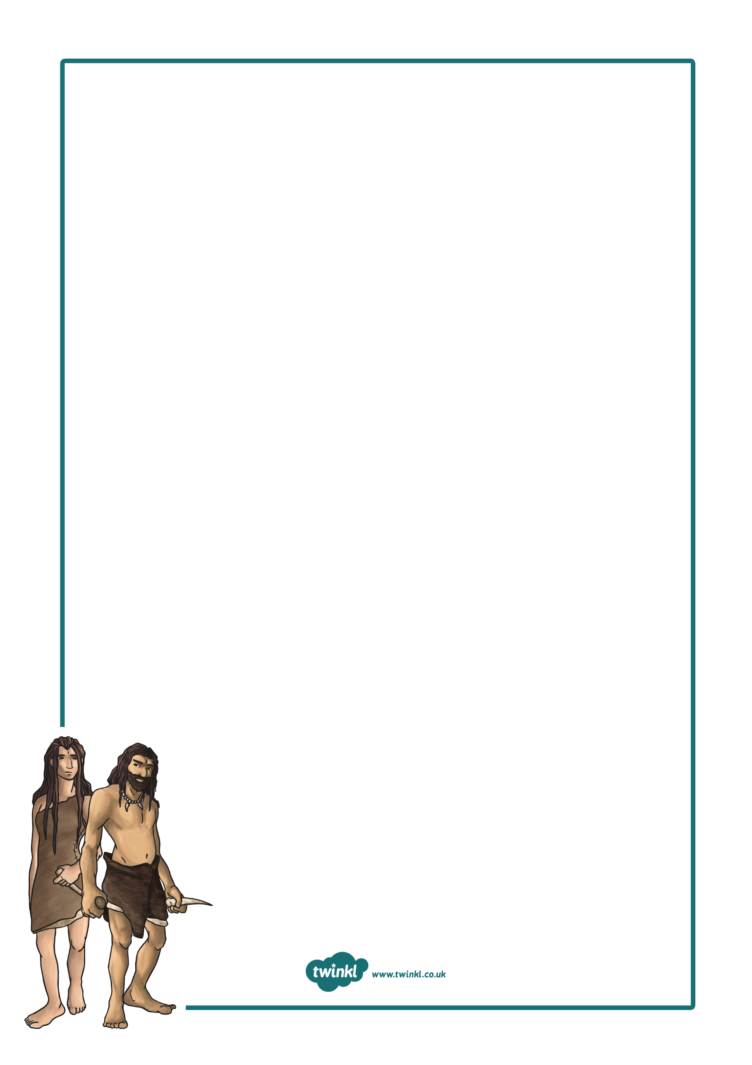
What was it like to be a prehistoric person?

LC1: What does prehistory mean?
LC2: How do we know so much about the Stone Age to Iron Age?
LC3: Can I use tone to create silhouette art of Stonehenge?
LC4 and 5: Why didn’t Stone Age people starve if there were no shops?
LC6: How and why was Stonehenge built?
LC7: What do grave goods tell us about the Bronze Age?
LC8: What was life like at an Iron Age hill fort?
LC9: How did Stone Age people use their environment creatively?
LC10: Where in the world did the Stone Age people settle?
LC11 and 12: Why did the Stone Age people settle in Skara Brae?
L13: Local village research.
Reflection Week: Do we have anything in common with Stone Age people?

Trip: Field trip to local village
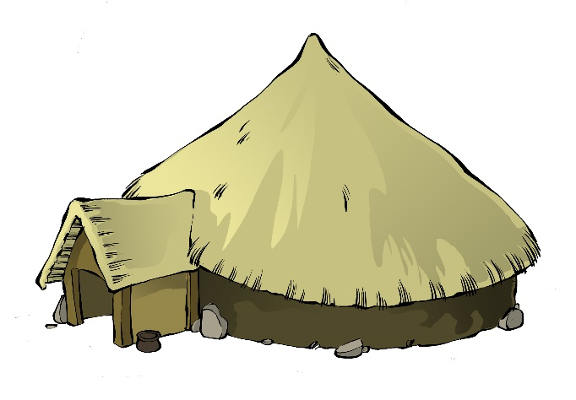
Home Learning Task:

