

**Word Wall**

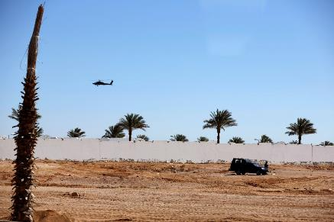

Look at the poster.

* What can you see?
* What do you like?
* What don’t you like?

Can you add an adjective (describing word) to any of the things you can see, like or don’t like? E.g. **dusty** tracks, **spiky** trees.

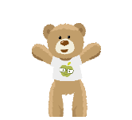

Make a collection of vocabulary and record on the bricks below to create a word wall!

Use your word wall to write a sentence describing the poster.