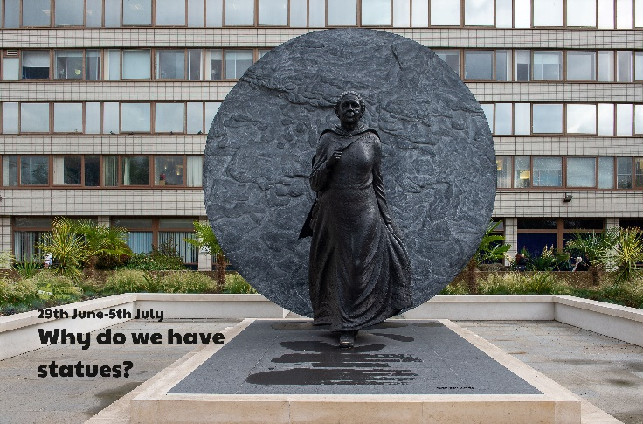

Statues are often life-size or larger. Measure how tall you are and record. Can you estimate the height of an adult in your home? Measure them and find out. Estimate and measure the height of others in your family.

Have you heard of a living statue? They are people who pose as statues. They often wear statue-like make-up and can stand very still! Can you pretend to be a statue? What will you wear? What position will you stand in? How long can you remain still for?

Play a game of musical statues!

Write a statue description. What is the statue made from? Metal, stone? Can you describe the material? Cold, hard? Is the statue a person, an animal or something else? What are they doing? How would you describe their eyes? Staring, unblinking, happy, sad, lonely? When you look at the statue, how does it make you feel?

Make a sculpture/statue of somebody who you think deserves one for their achievements but does not have one. What material will you use? Clay, playdough, plasticine? What size will your statue be? How will you shape/mould your statue?

Plan and write a biography of someone you think deserves a statue to celebrate their achievements. Begin by researching their life. Where/when were they born? What was their childhood like? What was their adulthood like? What have they achieved? Why should they be remembered? Write your biography remembering to use third person, past tense, vary sentence openers and use interesting vocabulary and punctuation.

**Learning from Home**

Use the ideas below, alongside this week’s resource, to support your home learning.