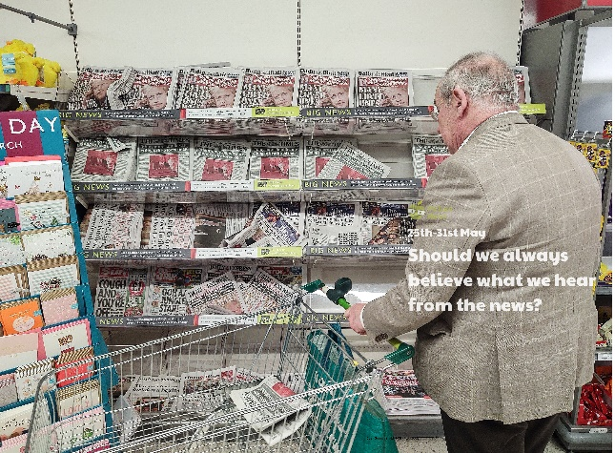

Explore the history of media. Can you find out when the television was invented? What was wireless telegraphy? When was the internet invented? How has social media impacted the spread of news?

Find out about something that is happening in the news at the moment. Perhaps you could use the Picture News Paper or watch a clip from BBC Newsround? Draw a picture to show the news story.

Think about an incident or event since your time in lockdown e.g. a family game night, learning a new skill, creating a meal, camping in the garden. Turn the event into a news report! You could create a newspaper, television report or an interview. Include: Who? What? Where? When? Why? Report in third person – she, he, they. Use past tense – it has already happened. Make sure it is true! If possible, share them with others in your class or school so you can see everyone’s news!

Use some of the Picture News paper stories. Can you find out where the story is from? Use a world map to locate it.

Media Maths! Use the home learning resource to explore percentages.

Quite often, the news on the TV or the radio begins and ends with music. Sometimes we call this a jingle. It is usually quite catchy, simple and easily recognised. Listen to the music found at the start of BBC Newsround or the Picture News Virtual Assembly. What do you like/dislike about it? Can you create your own news jingle?

**Learning from Home**

Use the ideas below, alongside this week’s resource, to support your home learning.