**R.E (Discovery RE)**

**Theme:** Jesus as a friend

**God/Creation Key Question:** Was it always easy for Jesus to show friendship?

**Religion:** Christianity

**Mathematics**

(White Rose)

**Number and Place Value (Within 20)** Count forwards and backwards and write numbers to 20 in numerals and words. • Numbers from 11 to 20. • Tens and ones. • Count one more and one less. • Compare groups of objects. • Compare numbers. • Order groups of objects. • Order number

**Geometry – Shape** Recognise and name 3D shapes. • Sort 3D shapes. • Recognise and name 2D shapes. • Sort 2D shapes. • Patterns with 3D and 2D shapes.

**Addition and Subtraction** • Add by counting on. • Find and make number bonds. • Add by making 10. • Subtraction – Not crossing 10. • Subtraction – Crossing 10 (1). • Subtraction – Crossing 10 (2). • Related Facts. • Compare Number Sentences

**Place Value (Within 50)** Numbers to 50. • Tens and ones. • Represent numbers to 50. • One more one less. • Compare objects within 50. • Compare numbers within 50. • Order numbers within 50. • Count in 2s. • Count in 5s.

**English**

**Poetry** - A simple rhyme based on a traditional rhyme.

**Instruction Texts-** To create a simple set of instructions.

**Stories with repetitive Patterns –** To write Narrative based on model text with innovation of character(s) and setting.

“Children also following a Talk 4 Writing course to help with story mapping.”

Jigsaw/PSHE

‘Dreams and Goals’

Growth and Green Fingers

Spring 1 – 2020

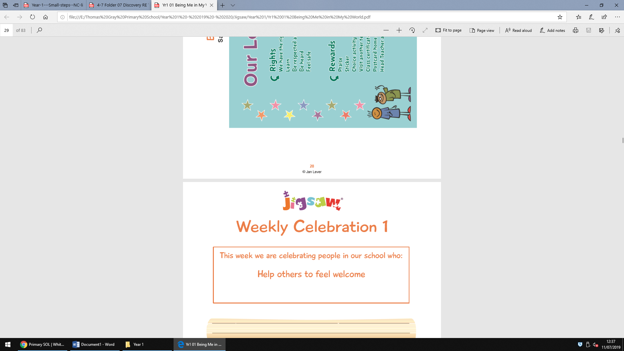

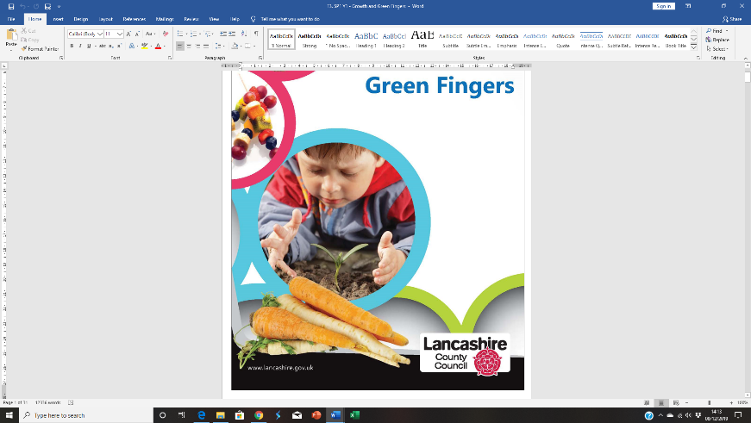

**Topic (Science – Plants Design Technology – Food and Art and Design )**

* Identify and name a variety of common wild and garden plants, including deciduous and evergreen trees.
* Identify and describe the basic structure of a variety of common flowering plants, including trees.
* Creating fruit kebabs through the design and make process.
* Trip to Asda Bootle
* Observational drawings of plants
* Explore a variety of fruits, finding out where they grow. Taste the fruits, discussing appearance, smell, texture, taste, sweetness etc.



**Computing:**

2Paint programs – creating plants and labelling using Purple Mash Software

To become more familiar with keyboard and mouse control.

To be able to log in and save work appropriately.

**Continuous Provision**

*‘Rainbow Challenges in areas’*