**Science Fiction:**

**The Water Tower**

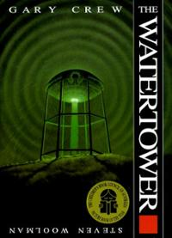

**Skills I will be taught in this unit:**

* **Use appropriate use of adverbials for place (and time)**
* **To use dashes and hyphens**
* **characters presented through blended action and description**
* **Expanded noun phrases**
* **Inference understanding of the text**
* **features of the science fiction genre.**
* **Basic Skills**

***Writing Outcomes: To write a science fiction story to entertain an identified audience…***