Geography:
‘World Geography’

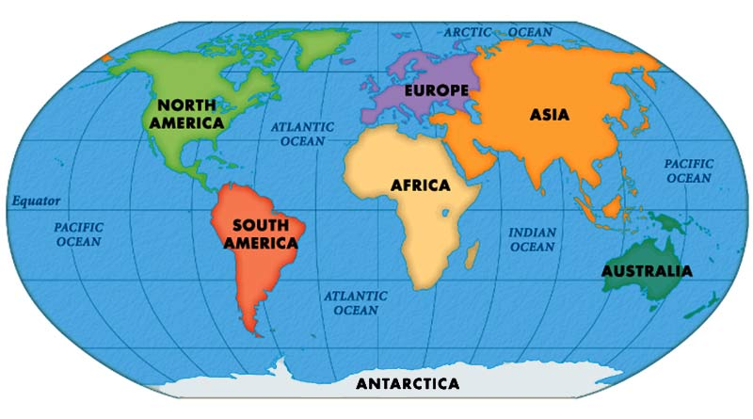

LC1: Can I identify the continents of the world?

LC2: Can I locate countries on a world map?

LC3: Can I find out about some of the key geographical features of a continent?

LC4: Can I use a variety of sources to identify human and physical features in a particular country?

LC5: Can I discuss/debate a natural disaster and locate these on a map?

LC6: Can I find out about physical or human features of different countries around the world?

