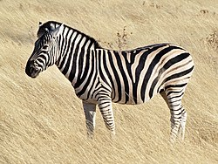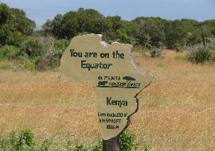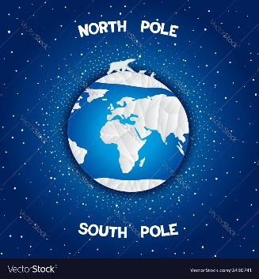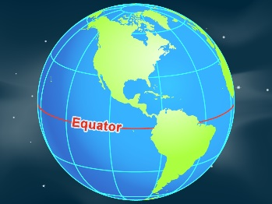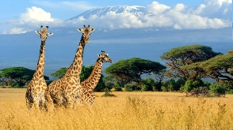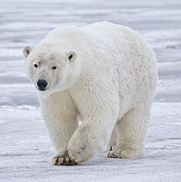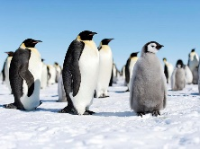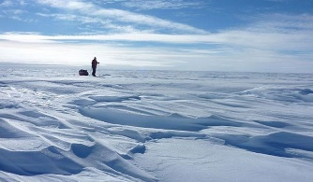

**Year 1 and 2 Autumn First Half Term**

**Learning Challenges**

**Can I find out what the Earth is like from space?**

**LC1: What does earth look like from space?**

**LC2: Can I name and Iocate the seven continents of the world?**

**LC3: Can I locate the hot and cold places on the earth?**

**LC 4: What is it like to live in the cold places on earth (near the poles)**

**LC5: What animals live in the cold places on earth?**

**LC6: What is it like to live in the hot places on earth (near the equator)**

**LC7: What animals live in the hot places on earth?**

**Homework Challenge: Can you make a space rocket together?**

**It can be made of any junk materials such as boxes, washing up bottles etc. We would like them brought into school before half term. Children who complete the task will receive a dip in the treasure box!**