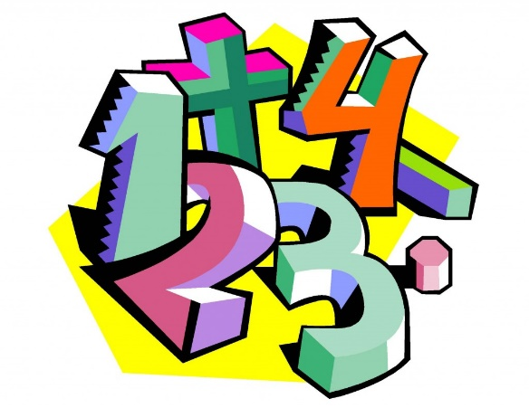

Count objects

Represent objects

Count, read and write forwards from any number 0 to 20

Count, read and writing backwards from any number 0 to 20

Count one more

Count one less

One to one correspondence to start to compare groups

Compare groups using language such as equal, more/greater, less/fewer

Compare numbers

Order groups of objects

Order numbers

Ordinal numbers (1st, 2nd, 3rd ….)

The number line

Block 1

Place Value

(Within 20)