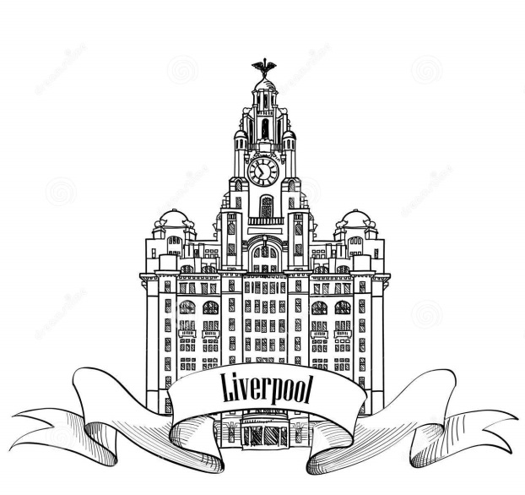
Why is it cool to live in Liverpool and why have the waterways always been so important for the city?

LC 1: Where is Liverpool?
LC 2: What has attracted people to live in Liverpool through the ages?
LC 3: Why has water always been so important in Liverpool?
LC 4: Why was the canal built and how did it change Liverpool?
LC 5: Why were the docks in Liverpool built and what was it like to work there?
LC 6: Has Liverpool always been a cool place to live?
LC 7 and 8: Has Liverpool got talent?
LC 9 and 10: What would attract people to Liverpool today?
LC 11: Why was Liverpool chosen to be the capital of culture?
Home learning challenge: to recreate a famous Liverpool landmark using a range of different materials. (Due week beginning 31.10.16)

