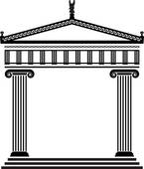**Ancient Greece**

**Summer Term 2017 Years 3/4**

**What did Greek civilisation do for us?**

**LC 1:** Where is Greece?

**LC 2/3:** What would I find in Athens and why do people go there?

**LC 4/5:** What is democracy and how has it evolved from Ancient Greece to today?

**LC 6:** Can I re-create a variety of Ancient Greek artefacts?

**LC 7/8:** Can I design my own Greek settlement using geographical features?

**LC 9:** What gods would you have worshipped in Ancient Greece?

**LC 10:** What are the Olympics and how have they changed over time?

**LC 11:** What impact did the Ancient Greek civilisation have on our modern world?

**LC 12:** Can I plan an Olympic festival? (mini project)

**Home learning task:**

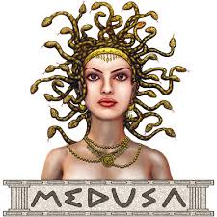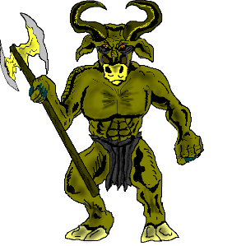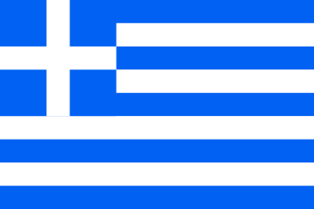Create a sculpture from any medium of a Greek mythical creature and research their story.

